SE-201: Software Quality Assurance

**Assignment # 3**

Submitted By:

Muhammad Memoon (20-SE-030)

Sabha Rani (20-SE-032)

Submitted To:

**Ma’am Farwa Aizaz**

HITEC UNIVERSITY, TAXILA

Contents

1. Introduction 4

1.1 Purpose: 4

1.2 Document Conventions: 4

1.3 Intended Audience and Reading Suggestions 5

1.4 Project Scope: 5

1.5 References 6

2. Overall Description 6

2.1 PRODUCT PERSPECTIVE 6

2.2 Product Features 6

2.3 User Classes and Characteristics 7

2.4 Operating Environment: 9

2.5 DESIGN AND IMPLEMENTATION CONSTRAINTS 9

2.6 User Documentation 9

2.7 Assumptions and Dependencies 10

3. System Features 10

3.1 Account Creation 10

3.1.1 Description and Priority 10

3.1.2 Stimulus/Response Sequences 10

3.1.3 Functional Requirements 11

3.2 Order Meals and Menu 11

3.2.1 Description and Priority 11

3.2.2 Stimulus/Response Sequences 12

3.2.3 Functional Requirements 12

3.3 Payment System 13

3.3.1 Description and Priority 13

3.3.2 Stimulus/Response Sequences 14

3.3.3 Functional Requirements 14

3.4 Create, View, Modify, and Delete Menu 15

3.4.1 Description and Priority 15

3.4.2 Stimulus/Response Sequences 15

3.4.3 Functional Requirements 15

3.5 Chef’s Portal System 15

3.5.1 Description and Priority 15

3.5.2 Stimulus/Response Sequences 16

3.5.3 Functional Requirements 16

3.6 Feedback System 16

3.6.1 Description and Priority 16

3.6.2 Stimulus/Response Sequences 16

3.6.3 Functional Requirements 16

3.7 Additional Features 17

4. External Interface Requirements 18

4.1 User Interfaces 18

4.2 Hardware Interfaces 18

4.3 Software Interfaces 18

4.4 Communications Interfaces 18

5. Other Nonfunctional Requirements 19

5.1 Performance Requirements 19

5.2 SAFETY REQUIREMENTS 19

5.3 SECURITY REQUIREMENTS 19

5.4 SOFTWARE QUALITY ATTRIBUTES 19

6. OTHER REQUIREMENTS 20

7. Appendix A: Glossary 20

8. Appendix B: Analysis Models 20

8.1 Data Flow diagrams 20

8.1.1 DFD Level 0 20

8.1.2 DFD Level 1 21

8.2 Sequence Diagrams 22

8.2.1 Order meals from the cafeteria menu 22

8.2.2 Create, view, modify, and delete cafeteria menus 22

8.2.3 GPS track of the order 23

8.2.4 Make payment 23

8.2.5 Writing the review 24

8.3 Use case diagram 24

8.4 Entity Relation Diagram 26

# Cafeteria Food Ordering System

# Introduction

This section discusses about the purpose, scope description and a short context about the various topics in this SRS document. In addition to this, this section also describes a list of abbreviations and definitions which will be used throughout the document.

## Purpose:

The purpose of this document is to give a detailed description of the, functional and non functionalrequirements for the “Online Cafeteria System” software. It will illustrate the purpose and complete declaration for the development of system. It will also explain system constraints, interface and interactions with other external applications. This document is primarily intended to be proposed to theShafqatChacha owner (customer) of cafeteria of Hitec Universityfor its approval.

## Document Conventions:

We will use bold letters to emphasis main topics and for all major functions of the system. Underlines will represent hyperlinks. Italic will represent acronyms and useful notes. We have used some acronyms in this document. Abbreviations and definitions of some useful terms used by us are given below.

|  |  |
| --- | --- |
| **COS** | Cafeteria Ordering System |
| **SRS** | Software Requirement Specification |
| **GUI** | Graphical User Interface |
| **ERD** | Entity Relationship Diagram |
| **DFD** | Data Flow Diagram |
| **Cafeteria Inventory System** | Cafeteria inventory system is the process of tracking theingredients coming in and out of your restaurant. For instance, your point-of-sale (POS) system may be able to automatically track theoretical inventory based on sales. |
|  |  |

## Intended Audience and Reading Suggestions

This document is intended for different types of readers such as canteen owner i.e. clients, system designers, system developer as well as testers. By reading this document a reader can learn about what the project is, and what the developer should develop. This document has a sequential overview of the whole project starting from introduction which includes sub parts such as purpose of the document, scope of the product being implemented and many such related sub parts. The document further describes overall description of the product which covers sub topics such as perspective and functionality of the product; operating system characteristics supported by the system and include some design and implementation constraints. The flow of the document then covers some functional and non-functional requirements of the system.

## Project Scope:

The Cafeteria Ordering System will allow a Student or a Faculty member to select desired meal from the Cafeteria Menu in which every item included present in a Café. The application also provides the user to have his/her own account from which, they can have a personal menu saved and can change it whenever they need. Receipt will be generated automatically having a unique number by which Student wait for their turn to receive packet from a serving person. The serving person (receptionist) concern is to confirm packet with payments and stamp the Receipt. Goal of this System is to provide easy way to select desire food item without having trouble. The DFD of the system is listed in 2.3

## References

<https://online.visual-paradigm.com/diagrams/features/dfd-maker/>

<https://ieeexplore.ieee.org/document/6984101>

<https://www.hitecuni.edu.pk/>

[Software Requirement Specification (SRS) and Parts of SRS | T4Tutorials.com](https://t4tutorials.com/srs-software-requirement-specification/)

# Overall Description

## PRODUCT PERSPECTIVE

The Canteen Management System helps the canteen manager to manage the canteen more efficiently and effectively, by computerizing meal ordering, billing and inventory controls. The system, processes transactions and stores the resulting data that will help the manager generate reports in order to make appropriate business decisions for the canteen. For example, knowing the number of customers for a particular time interval, the manager can decide whether more chefs or waiters are required. Moreover, he can easily calculate the daily expenditure and profit. The whole management system is designed for a general Computerized, Digital Canteen. Implementing this system will lead to hire less waiters and create an opportunity to appoint more chefs and better kitchen place to serve food faster. Customers can also make payment through debit and credit cards.

## Product Features

The main features of the product are:

**FE-1:** Order meals from the cafeteria menu to be picked up or delivered

**FE-2:** Create, view, modify, and delete meal service.

**FE-3:** Register for meal payment options

**FE-4:** Request meal delivery.

**FE-5:** Create, view, modify, and delete cafeteria menus

**FE-6:** Provide the user with a custom login and register page with a payment gateway

**FE-7:** Provide the user with the feature of writing the review to improvise in the COS standards

**FE-8:** Provide the user with the feature of customizing his own menu in the COS account and storing it as order custom meal option.

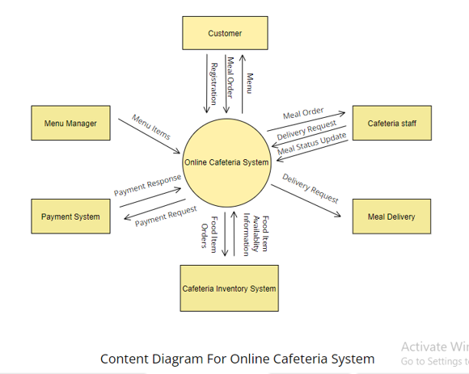

## User Classes and Characteristics

**UC-1: Customer:** A customer is a student, teacher or faculty member who views the menu, selects desired food item, orders it, customize his own meal and pay the bill. The customer will have to register in the COs, to enjoy the services and customize and order meals and for the payment options. The customer can give reviews to the cafeteria.

**UC-2: Manager:** The cafeteria manager plays a vital role. He manages all the online meal requests and responds to them. He can edit items and prices in cafeteria menu. He can update daily menu and can add specials offers. He checks the payment receipts and maintains an account for all payment done.

**UC-3: Chef :** Chef can be more than 1 person who will receive the Order from the System and Prepare the Food according to the System information passes to Chef. His work is just to make sure that Meal is ready within Time expected.

**UC-4: Serving Person:**A Serving Person is an employee at the Cafeteria, who will deliver the ordered meals from the cafeteria’s Kitchen to Customer. There may be more than 1 potential Person who will serve.

**UC-5: Delivery Man:** After the customer places an order, and ask for delivery the manager assigns the delivery task to the deliverer. He has to follow the delivery instructions and deliver the food in-time from kitchen to the correct place and person. The delivery will be tracked and the GPS live tracker will help in locating the information of the delivery person.

**UC-6: Bank:**  The bank is an important use case, as every transaction that is made from the customer through the COS, the bank has to approve the transaction and check if it is processed or not.

**UC-7: Customer Reviewer:**  The customer reviewer is an important use case, which helps the user’s reviews to be reached to the manager. The reviews inputs and comments given by the user will be reviewed by the reviewer and takes it to the manager for better improvement of the service through COS.

## Operating Environment:

**OE-1:** The Cafeteria Ordering System shall operate with like following Windows: Windows 2000, Windows XP server pack 3, Windows 7, Windows 8, 8.1 & Windows 10 as well.(32-bit & 64-bit both).

**OE-2:** The Cafeteria Ordering System shall operate well on Linux and Mac systems.

**OE-3:** The Cafeteria Ordering System shall operate well on all operating systems of Mobile phones.

**OE-4**: The Cafeteria Ordering System should be user friendly.

## DESIGN AND IMPLEMENTATION CONSTRAINTS

**DIC-1:** The Cafeteria Ordering system’s code shall be programmed in **C++** programming language, considering the software’s flexibility to operating in different platforms.

**DIC-2:** The system shall use My SQL database for storing the information

**DIC-3:** Signal Protocol shall be configured in Cafeteria Ordering System for ensuring the security from third party hackers.

**DIC-4:** Only the menu manager shall have the access to edit the menus.

## User Documentation

**UD-1:**  The system shall provide a very simple interface which should be user friendly and easy for them to understand and operate better.

**UD-2:** The system shall provide an online help system in Application that describes and illustrates all system functions.

**UD-3:**  The system shall provide the user (customer) with the privacy policy and the terms of use for proper usage of the application.

## Assumptions and Dependencies

**AS-1:** The cafeteria is open for breakfast, lunch, and dinner every day when university is open.

**DP-1:** The Cafeteria ordering system is highly dependent on the internet connection, as COS will be a web application, in which all the orders and order processing will be carried out only through internet connectivity.

# System Features

## Account Creation

### Description and Priority

This feature allows user to create account. There are two portals one for customer login and second one for Cafeteria Staff and café Manager.

Priority=High

### Stimulus/Response Sequences

**Stimulus:** User request to sign up for system.

**Response:** System will ask User name, id, email address, Phone number and Password.

**Stimulus:** User request to sign in for system.

**Response:** System will ask User name or email address and Password.

If the user enters correct email and Password system will allow user to login into the system.

**Stimulus:** User request to forget password.

**Response:** System will send recovery number to Email address or phone number.

If the user enters correct recovery number system will allow user to change his/her password.

### Functional Requirements

|  |  |  |
| --- | --- | --- |
| **AC-1** | New User | The system should enable a new user to register to the system by entering Information like Name, Email, Phone Number, Password and Department. |
| **AC-2** | Registered User | The system should Authenticate and allow already registered user to login on the web app by entering email and password. |
| **AC-3** | Forgot Password | The system should enable a registered user to change his password if forgotten by sending recovery code to his email or phone number. |
| **AC-4** | Error Message | The system should generate an error message in case of wrong data entry. |
| **AC-5** | New Employee | The system should enable a new employee to register by selecting employee option to the system by entering Information like Name, Employee ID, Phone Number, Password and Designation. |
| **AC-5** | Registered Employee | The system should Authenticate and allow already registered user to login on the web app by entering employee id and password. |

## Order Meals and Menu

### Description and Priority

Cafeteria Customer whose identity has been verified may order meals from menu which will be display on home screen of the application either to be delivered to his office or to be picked up in the cafeteria. The customer may cancel or change a meal order if it has not yet been prepared.

Priority = High.

### Stimulus/Response Sequences

**Stimulus:** Customer requests to place an order for one or more meals.

**Response:** System queries Customer for details of meal(s), payment, and delivery instructions.

**Stimulus:** Customer requests to change a meal order.

**Response:** If status is **“Accepted,”** system allows user to edit a previous meal order.

**Stimulus:** Customer requests to cancel a meal order.

**Response:** If status is **“Accepted”** system cancels a meal order.

### Functional Requirements

|  |  |  |
| --- | --- | --- |
| **OM-1** | Home Screen | The system should displays home screen including customize a meal, Most rated recipes, account activity, meal plan and a search bar on the top of the screen. |
| **OM-2** | Search bar | User enters his meal’s keyword or the on the search bar. COS displays list of available options for the keywords entered by the user. |
| **OM-3** | Place Order | The system should let customer who is logged into the Cafeteria Ordering System place an order for one or more meals. |
| **OM-4** | Order Place Register: | The system shall confirm that the Customer is registered into  the system if the customer is not registered the system shall give the Customer options to register now and continue placing an order. |
| **OM-5** | Order Delivery Select: | The customer will specify whether the order is to be picked up  Or delivered. |
| **OM-6** | Order Deliver Location | If the order is to be delivered then the customer will provide a  Valid delivery location. |
| **OM-7** | Order Menu Date | The system shall display a menu for the specified date. |
| **OM-8** | Available Food | The menu for the current date shall display only those food  items for which at least one unit is available in the cafeteria’s inventory. |
| **OM-9** | Number of units | The system shall allow the user to indicate the number of  units of each menu item that he wishes to order. |
| **OM-10** | Multiple meals | The system shall permit the user to order multiple identical  meals, up to the fewest available units of any menu item in the order. |
| **OM-11** | Maximum Number of meal | If the user orders more units of a menu item than are  presently in the cafeteria’s inventory, the system shall inform  the Patron of the maximum number of units of that food item  that he can order. |
| **OM-12** | Edit or cancel option | If the available inventory cannot fulfill the number of units  ordered, the user may change the number of units ordered,  change the number of identical meals being ordered, or cancel the meal order. |
| **OM-13** | Order Confirm Display | When the user indicates that he does not wish to order any  more food items, the system shall display the food items  ordered, the individual food item prices, and the payment amount, |
| **OM-14** | Order Confirm Prompt | The system shall prompt the user to confirm the meal order. |
| **OM-15** | Order Not confirm | If the user does not confirm the meal order, the user may  either edit or cancel the order. |
| **OM-16** | Previous Orders | The system shall permit the Patron to view any meals he has  Ordered within the previous six months. [Priority = Medium] |

## Payment System

### Description and Priority

User can register his credit card details in COS application. User shall maintain those details under ‘My Account’ button. COS will prompt user to use the registered card details or pay using new card at the time of checking out the order before placing it. If the user has not registered his card details, user can pay at the time of checking out the order before placing it.

### Stimulus/Response Sequences

**Stimulus:** Customer will confirm order and select credit card option for payment.

**Response:** System will ask Customer for detail of card and authenticate that detail with payment system and confirm the payment and order.

### Functional Requirements

|  |  |  |
| --- | --- | --- |
| **PY-1** | Payment option | When the user indicates that he is done placing orders, the  system shall ask the user to select a payment method. |
| **PY-2** | Credit card And Cash option | If the meal is to be picked up in the cafeteria, the system shall  let the user choose to pay by credit card or by paying  cash at the time of pickup. |
| **PY-3** | Order Payment deduct | If the user confirmed the order and selected payment by  Credit card, the system shall issue a payment request to  the Bank system. |
| **PY-4** | Order Payment Confirm | If the payment request is accepted, the system shall display a  message confirming acceptance of the order with the payment  Deduction transaction number. |
| **PY-5** | Order Message to cafeteria staff | Send a message to the Cafeteria Inventory System and to the  cafeteria chef with the Number of units of each food item in  the order. |
| **PY-6** | Update Menu and Inventory | Update the menu for the current order’s order date to reflect  Any items that are now out of stock in the cafeteria inventory. |
| **PY-7** | Order Failure | If any step of Order done fails, the system shall roll back the  transaction and notify the user that the order was unsuccessful,  Along with the reason for failure. |

## Create, View, Modify, and Delete Menu

### Description and Priority

This feature allows the menu manger to create, view, modify, and delete cafeteria menus.

**Priority=High**

### Stimulus/Response Sequences

**Stimulus:** Manager will request to create, modify or delete cafeteria menu.

**Response:** System will ask Manager about menu detail. After manger enter menu details system will displays a ‘Menu updated successfully’ message to the menu manager.

### Functional Requirements

|  |  |  |
| --- | --- | --- |
| **ME-1** | Create Menu | The system should provide Create Menu option to the manager  The manager will create menu by adding menu details. |
| **ME-2** | Modify Menu | When the menu is created the system should provide option to  Modify menu. |
| **ME-3** | Delete Menu | The system should provide an option to delete already created menu. |
| **ME-4** | Menu View | After the menu is updated the user can view the new modified menu in the application. |
| **ME-5** | Menu Save | If the menu is updated and not saved, the updated menu will not be displayed in the application and will provide the user with the information that update is not successful and has to re update the details |

## Chef’s Portal System

### Description and Priority

This feature show all the active order to the chef and allow him to prepare the meal according to the order and then he will mark order prepared on app and will give meal to the serving person or delivery men.

Priority=High

### Stimulus/Response Sequences

**Stimulus:** Whenever the customer confirm an order.

**Response:** System will send a message to the chef with the number of unit of each meal in the order.

### Functional Requirements

|  |  |  |
| --- | --- | --- |
| **CF-1** | Display all order | The system should display all the order to the chef. |
| **CF-2** | Display Status | The system should Enable chef to display the status of each  Order either “Preparing order” or “Ready to pick up”. |

## Feedback System

### Description and Priority

User should have the feature to add his feedback about the Quality of food, Quality of Service and Experience in ordering the food through cafeteria. User’s feedback will be monitored directly by the Menu-Manger.

Priority=Medium

### Stimulus/Response Sequences

**Stimulus:** Whenever the customer select feedback option.

**Response:** System will queries about user experience and problem.

### Functional Requirements

|  |  |  |
| --- | --- | --- |
| **FD-1** | Feedback | Enable a registered user to submit a Feedback on the App,  which contains a detailed explanation to his problem if any. |
| **FD-2** | Display to admin | Enable the admin to view, open and closed the submitted  Feedback. |
| **FD-3** | Response | Enable the admin to post a reply to the Feedback given |

## Additional Features

|  |  |  |
| --- | --- | --- |
| **AD-1** | **Login With Facebook** | User has the preference to register with COS application through Facebook. User can share his activities with COS in Facebook, like ‘Ordered and Enjoyed Chicken Biriyani from Cafeteria – Simply Delicious’.  Sharing those activities in Facebook, builds up Cafeteria reputation among the customers. Sharing activities in Facebook, promotes Marketability for Cafeteria restaurant.  **Priority = Low** |
| **AD-2** | **Order custom meals** | User shall order a new meal that is not available in cafeteria menu.  User shall provide the style of the food and the ingredients to customize the order.  **Priority = Low** |
| **AD-3** | **Track order status** | Allow User to track his meal order, so that user shall plan his activity with respect to order delivery.  **Priority = Low** |

# External Interface Requirements

## User Interfaces

**UI-1:** The Cafeteria Ordering System screen displays should Color matched with Hitec University [Website](https://www.hitecuni.edu.pk/) Color.

**UI-2:** The system shall provide a help button from each displayed page on GUI to explain how to use that page.

**UI-3:** The Web pages shall permit complete navigation and food item selection using the keyboard alone, in addition to using mouse and keyboard combinations.

## Hardware Interfaces

We have hardware Interfaces like when we are generating a receipt (printing receipt), and displaying order number on other screen.

## Software Interfaces

**SI-1:** Cafeteria Inventory System

**SI-1.1:** The COS shall poll the Cafeteria Inventory System to determine whether a requested food item is available.

**SI-1.2:** When the Cafeteria Inventory System notifies the COS that a specific food item is no longer available, the COS shall remove that food item option from the display of menu for the current date.

## Communications Interfaces

**CI-1**: The Cafeteria Ordering System shall send an e-mail message to the Receptionist to report any problems with the meal order or delivery after the order is accepted.

**CI-2:** - The Cafeteria Ordering System will send the confirmation message on the successful completion of order and receipts generated to the user through an email.

# Other Nonfunctional Requirements

## Performance Requirements

**PE-1**: The system should support more than 1000 user to checkout at the same time.

**PE-2**: On the successful completion of the transaction from the user, the details of the transaction have to be stored in the database for six months and can be retrieved when needed in less than 3 seconds.

**PE-3:** All the pages generated by the system shall be fully downloadable in no more than 10 seconds over a 100KBps modem connection.

## SAFETY REQUIREMENTS

**SAF-1:** We should highlight spicy foods and high calorie foods in the menu in case users order the foods that they don’t want.

## SECURITY REQUIREMENTS

**SEC-1:** User’s personally information like phone number and credit card information should be encrypted before storing in databases.

**SEC-2:** The system shall permit only cafeteria staff members who are on the list of authorized Menu Managers to create or edit menus.

## SOFTWARE QUALITY ATTRIBUTES

**SQA-1:** The system should be available 24/7.

**SQA-2:** The Android APK size should less than 50M.

**SQA-3:**If the connection between the user and the system is broken prior to an order being either confirmed or canceled, the Cafeteria Ordering System shall enable the user to recover an incomplete order.

**SQA-4:**  The system should be maintainable in case of any bug the system should be recovered and data should not lost.

# OTHER REQUIREMENTS

**OR-1:** Various recipes that has been rated as favorite by majority of Patrons, shall be collected and displayed at the home screen when Patron opens the COS

**OR-2:** The user can set the mobile application to his/her preferred language. (English or Urdu)

**OR-3:** We should use cache to speed up our application.

# Appendix A: Analysis Models

## Flow diagrams Data

### DFD Level 0



### DFD Level 1

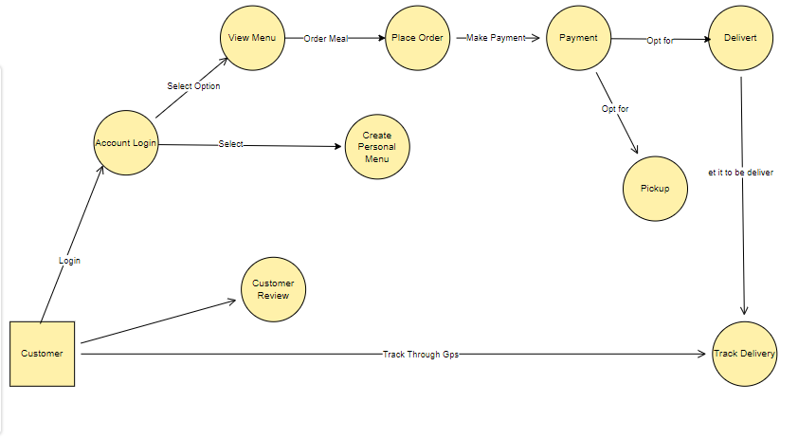

## Sequence Diagrams

### Order meals from the cafeteria menu

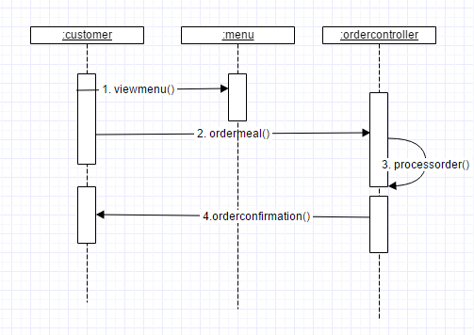

### Create, view, modify, and delete cafeteria menus

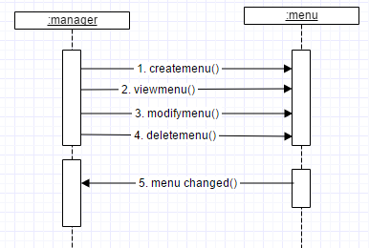

### GPS track of the order

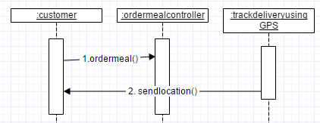

### Make payment

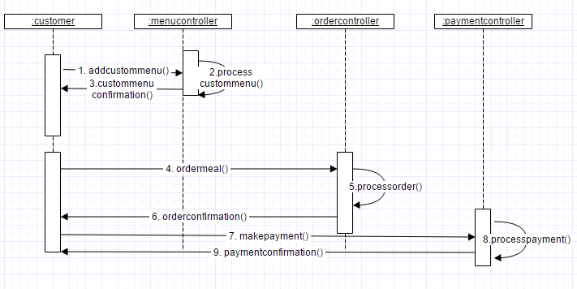

### Writing the review

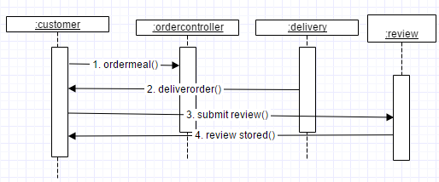

## Use case diagram

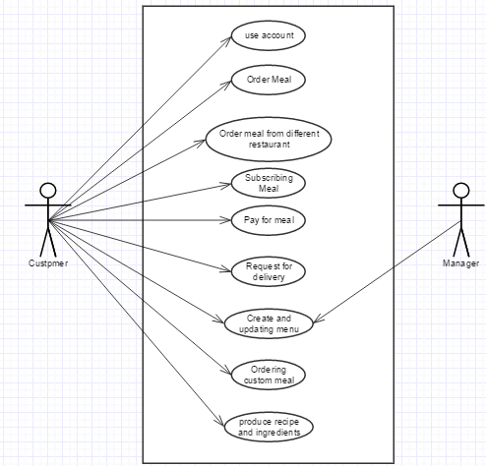

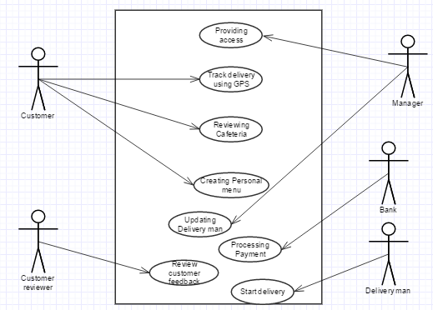

**Fig: Overall description of the use cases**

## Entity Relation Diagram

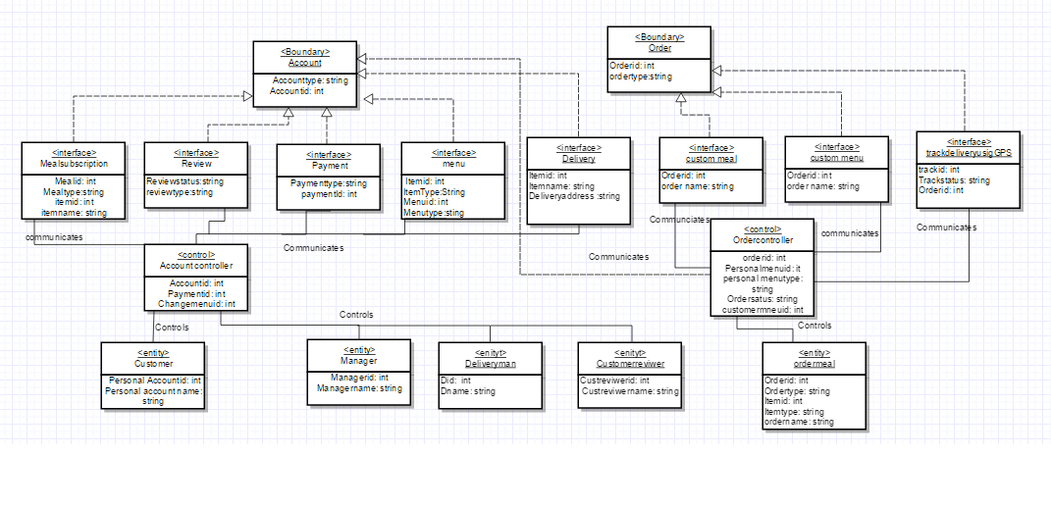

**THANK YOU**